
4



Solution Design
Document
Table of Contents
I. Purpose 3
II. Automated process details 4
3 Runtime guide 5
3.1 Architectural structure of the Master Project 5
3.2 Master Project Runtime Details 5
3.3 Project name 1 6
3.4 Project(s) workflows 6
3.5 Packages 7
3.6 Architectural structure of the Master Project 7
4 Other Details 8
Future Improvements 8
Other Remarks 8
5 Glossary 9

Purpose

The main purpose of the system is to automatically detect IFC assets in cubemap panoramas using machine learning.
- Robustness: modularized components for frontend, backend, ML, and database layers
- Scalability: containerized microservices deployable locally
- Efficiency: optimized detection and review workflows for near real-time labeling.
- Replicability: Docker compose setup for uniform development and deployment.
- Reusability: services can be exdtended or reused in similar computer vision pipelines.
The information herein is targeted primarily at the developers that will initially implement the solution and subsequently at the support developers in case of change requests.

Automated process details
Details filled in need to reflect the actual information for the Master Project released for production. The following table will be populated:

Item | Description
Master Project Name | 360 Degree IFC Asset Detection and Review Prototype
System Type | Full-stack microservice application
Orchestrator | Docker compose manages containers for each service
Scalable | Yes, each container can scale independently
Primary Frameworks | React (Vite), Node.js, Python (YOLO), PostGIS
Version Control | GitHub repository shared among team members
Database | Local PostgreSQL with spatial extension (PostGIS)
Storage | Local file system for images and model outputs
ML Service | YOLO based detection model running in Docker container
Deployment | Primarily local

Runtime guide

Master Project Runtime Details
Outlines the details of the automated process by filling in the table below.
ITEM NAME | DESCRIPTION
Production environment details | Runs locally via Docker Compose. Connects frontend, backend, ML, and database containers
Prerequisites to run | Docker Desktop installed. PostgreSQL database initialized with correct schema. YOLO model weights available locally.
Input Data | Cubemap panoramas stored as JPEG or PNG
Expected output | JSON records of detected IFC assets, including bounding boxes, class names, and confidence values.
How to start the automated process | Detection is triggered when a user uploads a panorama and requests analysis from the UI
Reporting | Basic backend logging
Security Policies | Token-based access for review actions, minimal local credential use.
Stored Credentials | Environment variables stored securely in the Docker .env file
Schedule Details | Manual initiation from UI
Multiple Resolutions Supported | Yes, all panoramas are resized automatically for model compatibility
Recommended Resolution | 2048x2048 per cubemap face

Project name:360 Degree IFC Asset Detection
ITEM NAME | DESCRIPTION  Fill in each section - empty fields are not allowed. If the section does not apply to your automation then mark as n/a.
Environment used for development  (name, location, configuration details etc) | Local Docker environment with Node.js backend and PostgreSQL database.
Environment prerequisites  (OS details, libraries, required apps) | Node.js v20+, Python 3.10+, Docker Desktop, React/Vite, YOLO model weights
Repository for project  (where is the developed project stored) | https://github.com/IronThorn17/ifc-asset-detection
Configuration method  (assets, excel file, Json file) | .env files for each service, Docker Compose handles shared environment variables
List of reused components | YOLO open-source detection model, React panorama viewer
List of new reusable components | Detection overlay component, review management system, and active learning retraining script

Add tables for as many projects as you need and fill them in.

Project(s) workflows
Workflows specific to: 360 Degree IFC Asset Detection
For the workflow files defined below please specify the input and output parameters.
Workflow Name | Description
Main Workflow | Orchestrates image ingestion, detection, and review cycle
Upload Panorama | Handles image upload from frontend and stores metadata in database
Run Detection | Executes YOLO inference on cubemap images and writes results to database
Review Detection | Allows user to confirm, reject, or reclassify detections via frontend

Packages
Include the list of packages and high-level description for each of them, to explain their purpose
Package Name | Description
Frontend-react-vite | Provides UI for panorama viewer and detection review
Backend-express-api | RESTful Node.js API for panoramas, detections, and reviews
ml-yolo-service | Python service that processes unreviewed panoramas using YOLO
Db-postgis | PostgreSQL container with PostGIS extension enabled for geometry data

Design Standards
- IEEE Std 1016-2009 – This is a standard for software design. Specifically, standards for creating SDDs.
- IEEE Std 830-1998 – This is a standard for creating a good SRS
- IEEE/EIA 12207.1-1997 – This is a standard that pertains to describing the software lifecycle.

Architectural structure of the Master Project
- Frontend (React + Vite):
  - Provides the 360 panorama viewer and detection review UI
  - Connects to the backend via REST API endpoints
  - Allows users to upload data to the database
- Backend (Node.js):
  - Manages API routes for image ingestion, detection retrieval, review actions, and exports
- Machine Learning (Python + YOLO):
  - Scans for unprocessed panoramas, performs inference, and saves results
  - Outputs detection metadata (class, confidence, and bounding boxes) to the database
- Database (PostgreSQL + PostGIS):
  - Stores panoramas, detections, review data, and retraining samples.
  - Handles geometry data for geolocation and mapping.
Context Model: 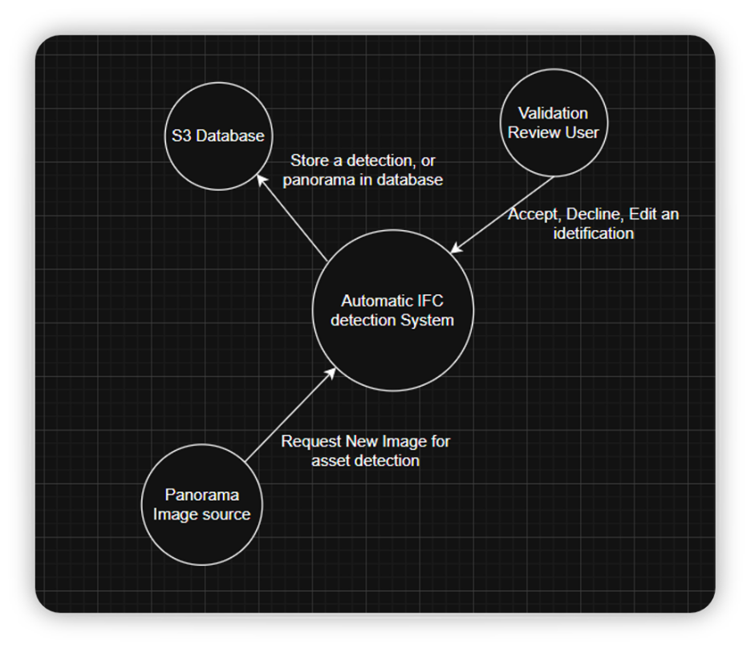

Component Diagram:
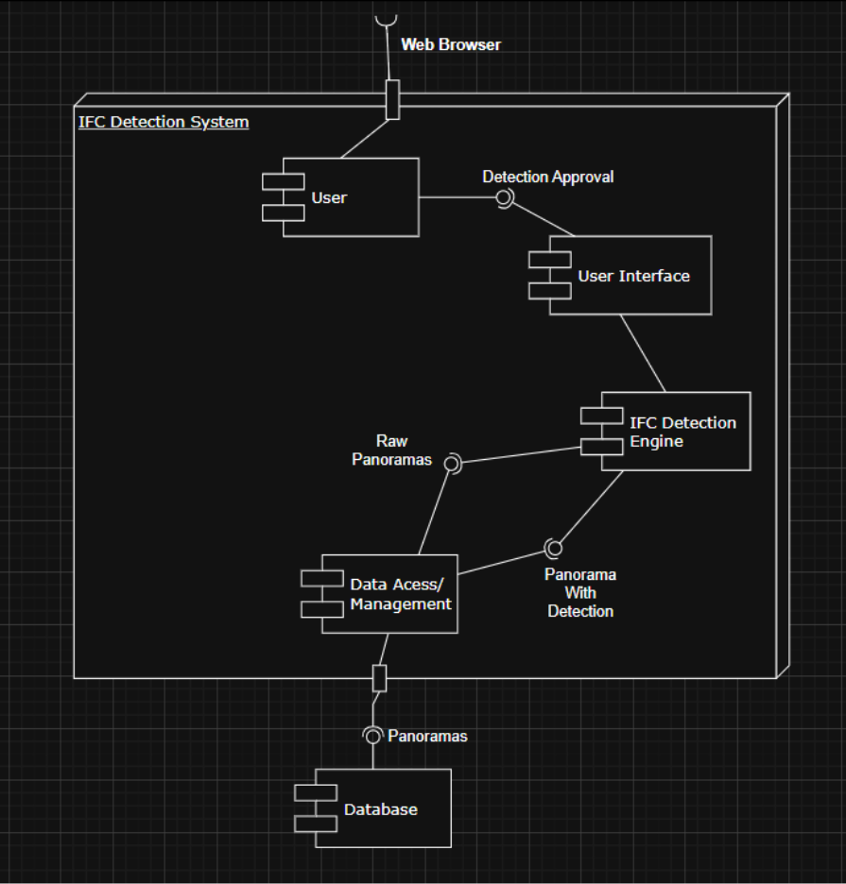

Main Flow Activity Diagram:
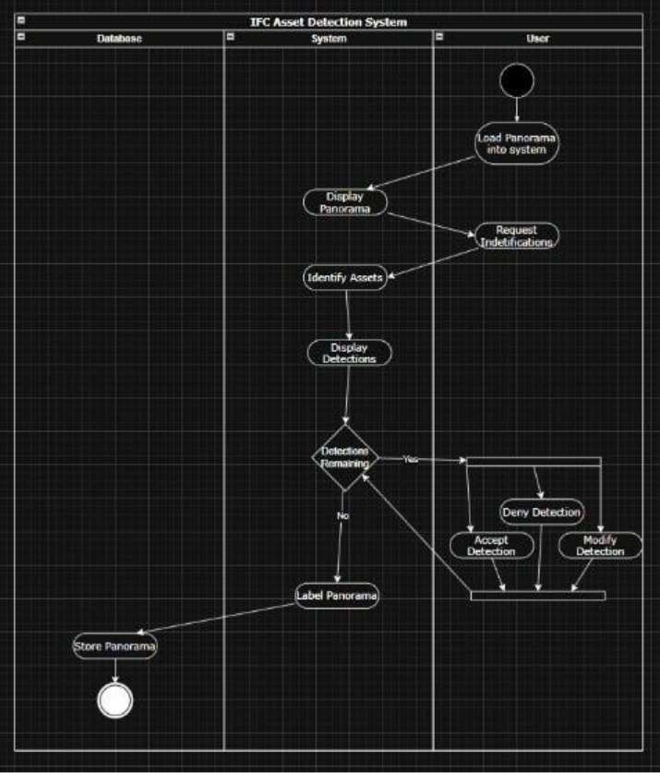

Image Loading Activity Diagram:
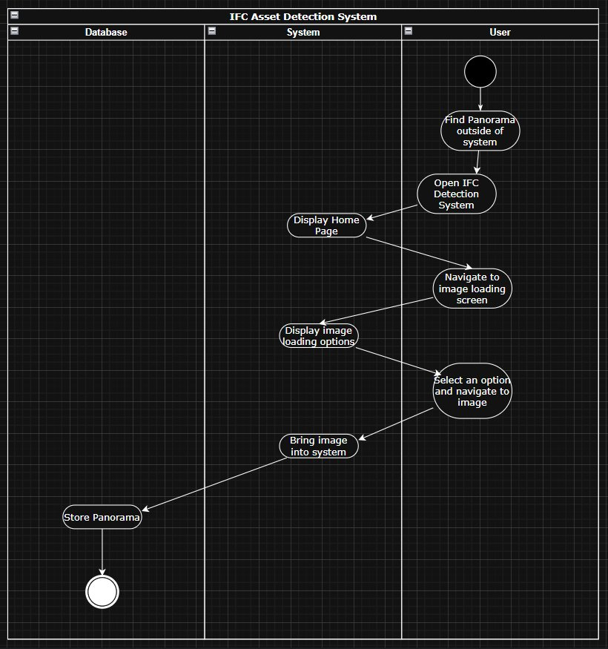

Create Asset Detection Activity Diagram:
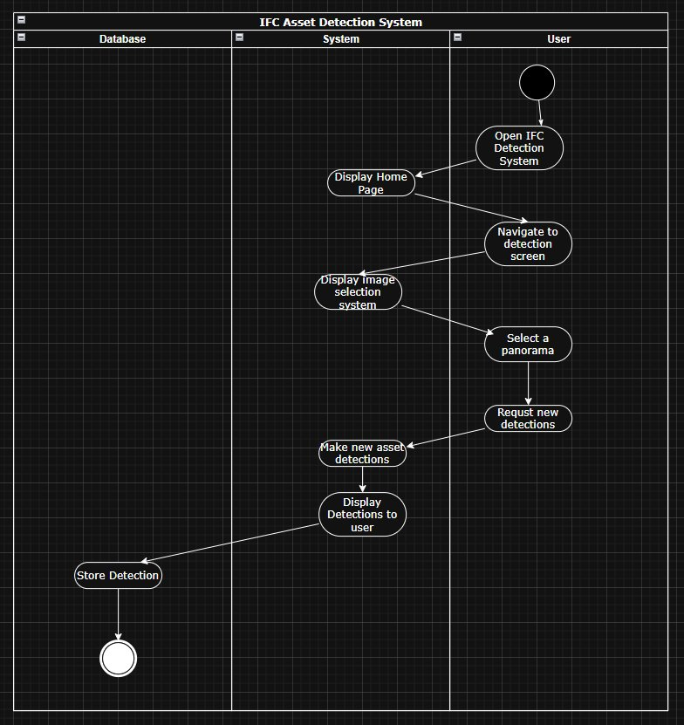

Review Detection Activity Diagram:
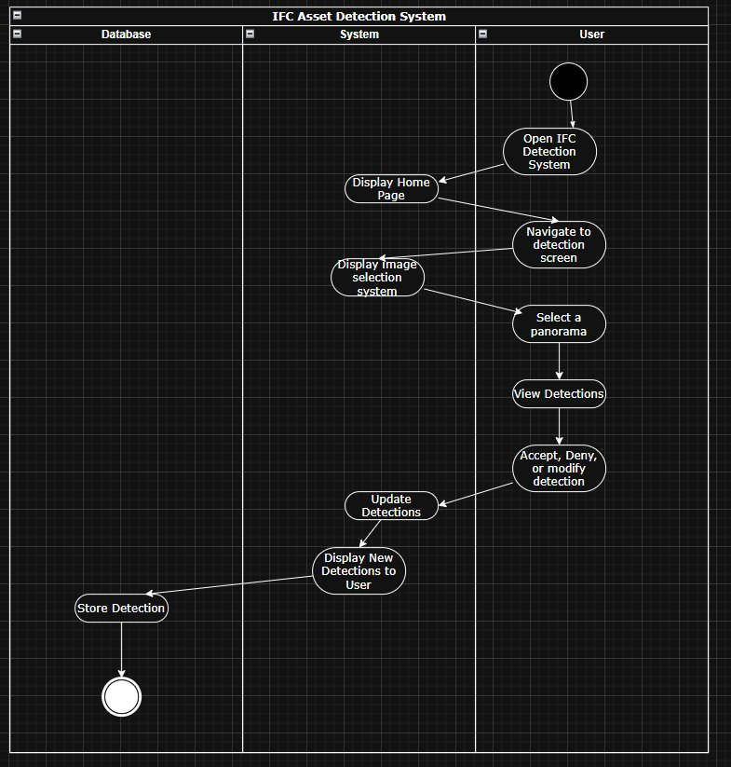

Display Detections Activity Diagram:
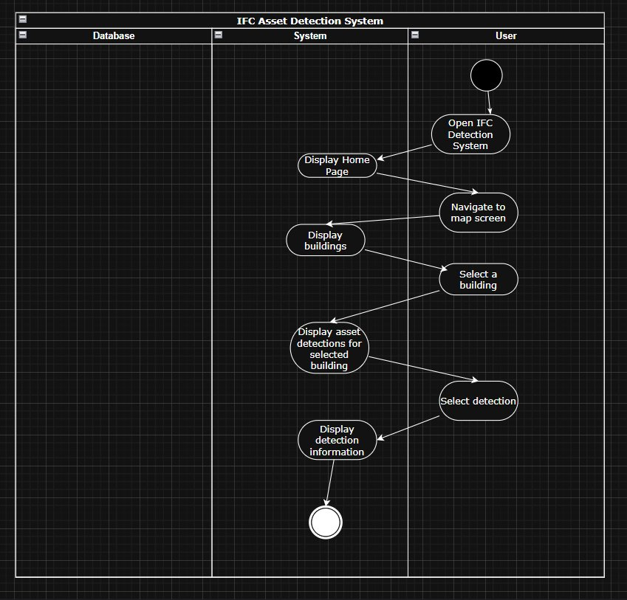

Deployment Diagram:
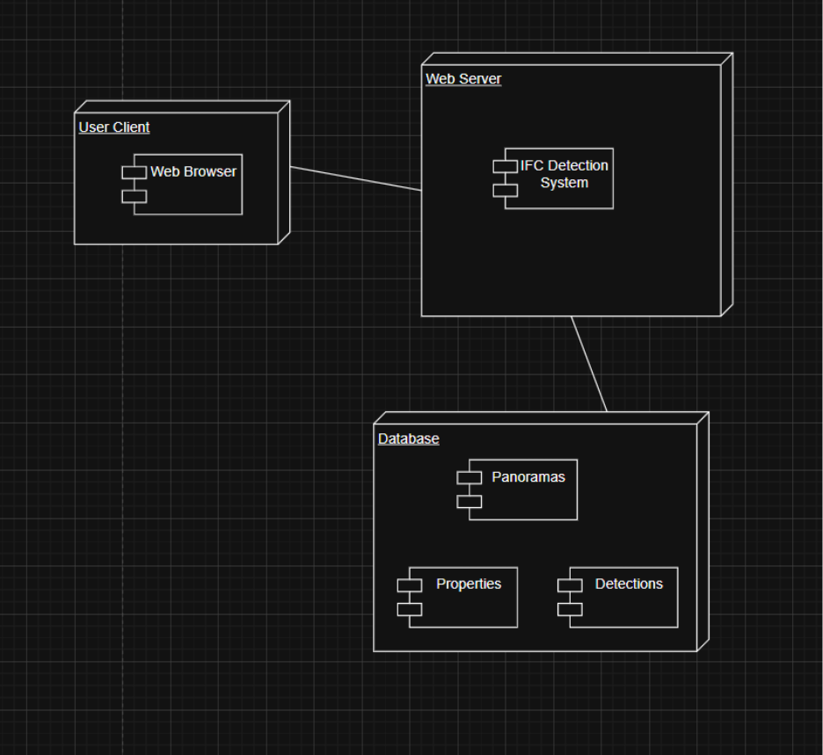

Use-Case Model:
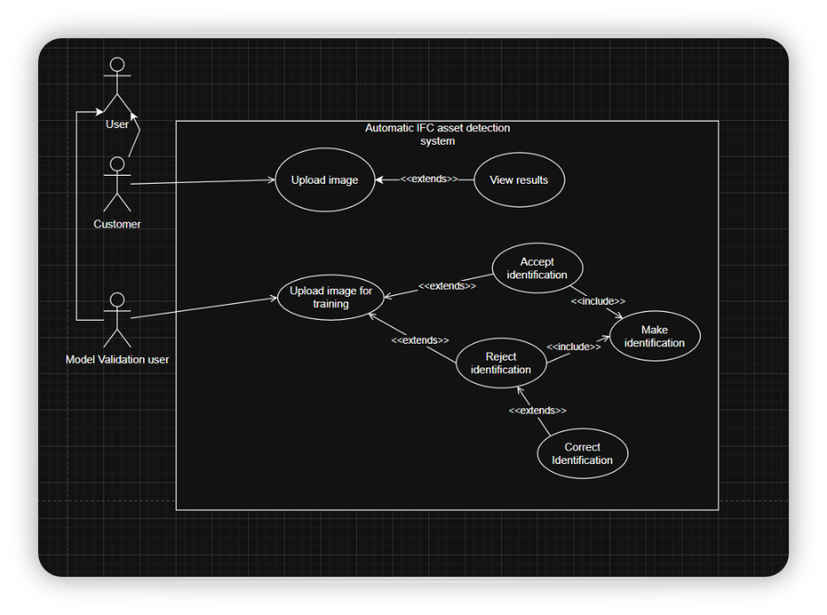

Other Details

Future Improvements
- Implement a cloud deployment pipleine (AWS)
- Add auto-retraining schedule based on QA batches.
- Improve model precision with larger labeled datasets.
- Integrate authentication and roles (Reviewer vs Admin)
- Add real-time inference to reduce batch latency
- Implement change detection for renovation tracking in future phases.

Other Remarks
- The system is designed to remain modular, new detection classes can be added by editing the YOLO configuration and class mapping table.
- A command-line retraining tool is available for model updates after QA approval.
- Developers should ensure all environment variables are stored securely in .env files and not committed to version control.

Glossary

The main terms used in the Solution Architecture Document are defined below:
Term | Definition
IFC | A standardized data model for building and construction elements.
Panorama | A 360 degree image captured by a camera and split into six cubemap faces.
Cubemap | A 3D representation of a panoramic image using six square faces
Detection | The automated identification of an asset by the ML system
Reviewer | A user who verifies system detections for accuracy
Active Learning | A training strategy where the system retrains on corrected labels from user feedback.
PostGIS | A spatial database extension for PostgreSQL
Confidence Score | A numerical measure of how certain the model is about a detection.

